|  |
| --- |
| HoloBio User Manual V1.0 |

|  |
| --- |
|  |

|  |  |
| --- | --- |
| Open-source GUI in Python for quantitative reconstruction and analysis (DHM/DLHM), in real time and offline.  V 1.0 |  |



ConteNT

Introduction 2

1. Installation Instructions 3
2. Main Menu 4
3. Common Interference Components 5

3.1 Main Control Panel5

3.2 Visualization Panel6

1. Offline Hologram Processing - DHM 7

4.1 Phase Compensation9

4.2 Phase Shifting 11

4.3 Numerical Propagation 13

4.4 Propagation Options15

1. Offline Hologram Processing - DLHM 17
2. Real-Time Hologram Processing - DHM 19

6.1 Compensation of Holograms from Digital Camera21

6.2 Compensation of Holograms from Previous Recorded Holograms 21

6.3 Particle Tracking 21

1. HoloBio Analysis Toolkits 23

7.1 Bio-Analysis 23

i) Dimensions 23

ii) QPI Measurements 24

iii) Microstructure Metrics 25

7.2 Filters 26

7.3 Speckle 27



|  |
| --- |
| INTRODUCTION |

|  |  |  |
| --- | --- | --- |
| HoloBio-GUI is an open-source, Python-based graphical user interface designed to simplify the use of Digital Holographic Microscopy (DHM) for biological research. The software was developed to bridge the gap between advanced optics and biological applications, providing researchers with an intuitive platform to reconstruct, analyze, and quantify samples information without requiring programming expertise.  The software integrates two primary modes of operation: Real-Time Processing and Offline Processing. Real-Time Processing enables live reconstruction and analysis of holograms at video frame rates using a connected digital camera, while Offline Processing provides advanced numerical tools for the reconstruction of previously recorded holograms. Both modes are complemented by specialized packages for Digital Holographic Microscopy (DHM) and Digital Lensless Holographic Microscopy (DLHM), ensuring compatibility with a wide range of experimental configurations, including in-line, slightly off-axis, and off-axis setups.  This manual is designed to guide users through the functionalities of HoloBio, from installation and mode selection to advanced reconstruction and analysis procedures. Each section is structured to provide step-by-step instructions accompanied by graphical references, ensuring accessibility for both novice and experienced users. By following this manual, researchers can fully exploit the capabilities of HoloBio to obtain reliable, reproducible, and quantitative insights from holographic data in diverse biological applications. | | |
| XXXXXXXXXXXXXXXXXXX XXXXXXXXXXXXXXXXXXXXXXXXXX XXXXXXXXXXXXXXXXXXXXXXXXXXXXXXXX XXXXXXXXXXXXXXXXXXXXXXXXXXXXX XXXXXXXXXXXXXXXXXXXXXXXXXXXXX | | |
|  |  |  |

|  |
| --- |
| INSTALLATION INSTRUCTIONS |

|  |  |
| --- | --- |
| Upon launch HoloBio, the Main Menu screen appears, providing access to all core processing **Fig. 1.** The interface is designed for quick navigation, allowing users to choose between real-time and offline hologram processing.  The main menu is divided into two packages:   * Real-Time Hologram Processing – For live acquisition and processing of holograms directly from a connected camera. * **Offline Hologram Processing** – For processing previously recorded holograms from local storage. | Fig. 1. Main menu of HoloBio, displaying the available processing modes (Real-Time and Offline) and microscopy configurations (DHM and DLHM). |

|  |
| --- |
| MAIN MENU |

In each processing mode, two options are available:

DHM (Digital Holographic Microscopy): Standard configuration for general DHM workflows.

DLHM (Digital Lensless Holographic Microscopy): Configuration for lensless holographic setups.

Specifications packages

* Real-Time Hologram Processing: This section grants access to real-time acquisition and visualization modules. By clicking either the DHM or DLHM button, the user is directed to the corresponding live-processing interface, optimized for immediate reconstruction of incoming holographic data from a connected camera. These modules are designed for responsive performance on standard laboratory hardware and are equipped with tools such as live phase visualization, Fourier inspection, and real-time filtering.
* Offline Hologram Processing: This section provides access to offline modules for the numerical reconstruction and analysis of previously acquired holograms. Users can load single images or video sequences and apply a variety of propagation and phase retrieval methods, depending on the chosen modality (DHM or DLHM). The interface dynamically adapts to support lens-based or lensless configurations, ensuring that relevant parameters and algorithms are presented contextually.

# 3.1 Main Control Panel

The Main Control Panel is a common element to all the working modes located at the top of all HoloBio interfaces (see Fig 2.). It provides access to essential file management, analysis, and display settings, independent of the selected processing mode.

The panel contains the following menus and controls:

* Load: Opens hologram or sample images into the workspace. Available options include:
  + Hologram – Loads a single hologram image from local storage.
  + Stack of Holograms – Loads a sequence of holograms.
  + Sample – Loads a reference sample image for testing or demonstration purposes.
* Tools: Provides quick access to auxiliary processing and analysis modules:
  + Bio-Analysis – Opens the biological analysis suite for quantitative evaluation of reconstructed amplitude and phase images.
  + Filters – Grants access to spatial filtering tools for image enhancement and color map for visualizations.
  + Speckle – Opens the speckle noise measurement and reduction module.
* Save: Stores processed results in standard image formats. Options include:
  + Save FT – Saves the Fourier Transform representation of the hologram.
  + Save Phase – Saves the reconstructed phase image.
  + Save Amplitude – Saves the reconstructed amplitude image.
* Theme: Changes the visual appearance of the interface:
  + Light – Activates a light color scheme.
  + Dark – Activates a dark color scheme.

|  |
| --- |
| 3. COMMON INTERFERENCE COMPONENTS |

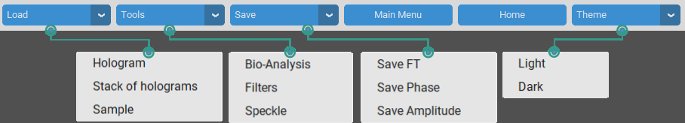

Fig. 2. Main menu bar of HoloBio with available tools and configuration options.

|  |
| --- |
| 3. COMMON INTERFERENCE COMPONENTS |

# Visualization Panel

The Visualization Panel is the central display area of HoloBio, present in all processing modes Fig. 3. It is divided into two main windows that allow users to inspect input hologram and its numerical reconstruction side by side.

* Hologram / Fourier Transform Window (1): Located on the left side, this window displays either the original hologram or its Fourier transform, depending on the selected option. A zoom control is available for detailed inspection of images.
* Reconstruction Window (2): Located on the right side, this window presents the numerical reconstruction of the hologram, which can be displayed either as a Phase Reconstruction or an Amplitude Reconstruction. A zoom control is also available to facilitate the evaluation of specific regions of interest.

Together, these two windows provide a synchronized workspace for comparing raw holographic data with its reconstructed representations, ensuring efficient analysis and interpretation.



Fig. 3. Visualization panel of HoloBio showing (1) the hologram/Fourier transform display and (2) the phase or amplitude reconstruction display.

|  |
| --- |
| 4. OFFLINE HOLOGRAM PROCESSING - DHM |

Selecting the Offline DHM option in the Main Menu opens the interface shown in Fig. 4. This workspace is organized into three main components to facilitate hologram reconstruction and analysis workflows.

* Main Control Panel (1): Located at the top of the interface, this panel contains the primary operational controls. It includes buttons for loading and saving datasets, accessing additional tool panels (Tools), returning to the main menu or home screen, and switching between available interface themes. For more details about its function, refer to the *Common Interface Components* section.
* Processing Methods Panel (2): Positioned on the left side of the window, this panel lists the available DHM processing methods: Phase Shifting, Phase Compensation, and Numerical Propagation. Selecting a method updates the control panel to display the corresponding parameters and tools relevant to the chosen process.
* Visualization Panel (3): Occupying the central and right sections of the interface, this panel provides the main display area for holographic data. It supports the visualization of the original hologram, or its Fourier transform on the left side, and either amplitude or phase reconstructions on the right side. For more details about its function, refer to the Common Interface Components section.



Fig. 4. HoloBio offline DHM interface with (1) main control panel, (2) processing methods section, and (3) dual visualization panel.

|  |
| --- |
| 4. OFFLINE HOLOGRAM PROCESSING - DHM |

In the Offline DHM module, the Processing Methods Panel (Panel 2) dynamically updates to display the controls and parameters relevant to the selected reconstruction method. The three available methods, Phase Compensation, Phase Shifting, and Numerical Propagation, each present a distinct set of options tailored to their respective workflows, see Fig. 5. When a method is selected, the panel adapts to provide: Method-specific configuration options, input fields for relevant optical system parameters, and controls for propagation settings and reconstruction output.



Fig. 5. Detailed configuration options in the Processing Methods Panel: (1) Phase Compensation, (2) Phase Shifting, and (3) Numerical Propagation.

|  |
| --- |
| 4. OFFLINE HOLOGRAM PROCESSING - DHM |

* 1. **Phase Compensation**

When the *Phase Compensation method* is selected in the Offline DHM module, the Processing Methods Panel is updated with controls specific to off-axis phase reconstruction (Fig. 6 panel 2). This method is designed for numerical reconstruction of holograms recorded in off-axis architecture.

The panel contains the following sections:

* Choose a Compensation Method: Offers multiple algorithmic approaches for phase compensation: *Semi-Heuristic*, *Tu-DHM*, *No Telecentric*, and *Vortex Legendre*. Each method implements a distinct compensation strategy tailored to specific optical configurations and aberration characteristics.

Advanced configurations parameters for the selected method can be accessed by clicking the Settings (⚙️) button.

* Loading Reconstruction Parameters: Allows input of essential optical parameters:
  + Wavelength - Specifies the wavelength of the light source used during hologram acquisition.
  + Pitch X and Pitch Y - pixel size of the digital camera used during hologram acquisition.
* Compensation Filter Options: Provides the choice between *Automatic* and *Manual* spatial filtering.
  + **Automatic** – Applies a predefined filter shape centered on the detected diffraction order between Circular and Rectangle.
  + **Manual** – Enables user-defined placement and adjustment of the filter. This mode offers greater control over size, position, and shape. Available options include None, Circular Coordinates, Circular Manual, Rectangle Coordinates, Rectangle Manual, Non-Telecentric Coordinates, and Non-Telecentric Manual.
* Propagation Options: Defines how the compensated complex field is propagated.
  + Modes: Fixed Distance, Z-scan Sweep, or Auto Focus.
  + Adjustable parameters: *Lateral Magnification*, *Distance*, *Min* and *Max* range, and propagation units.
  + Autofocus metric selection and optional visualization of the focus curve.

How to use it?

Step 1 – Load a hologram.

Step 2 – Choose a compensation method.

Step 3 – Define reconstruction parameters.

Step 4 – Configure the compensation filter.

Step 5 – Run compensation.

In the Visualization Panel, use the left window to review the Hologram/FT and the right window to toggle between Amplitude and Phase.



Fig. 6. Phase Compensation method displayed in the Offline DHM interface of HoloBio.



Fig. 7. Offline DHM interface showing the Phase Compensation method applied to red blood cells.

|  |
| --- |
| 4. OFFLINE HOLOGRAM PROCESSING - DHM |

Practical Example - Phase Compensation: To illustrate the use of the Phase Compensation method in the Offline DHM module, Fig. 7 shows the reconstruction of red blood cells. The hologram was acquired in an off-axis configuration and reconstructed using the *Semi-Heuristic compensation method*. The following parameters were defined in the *Loading Reconstruction Parameters panel*: wavelength λ = 633 nm and camera pixel size = 3.75 µm in both X and Y directions. In the Compensation Filter Options, the Automatic Circular filter was selected.

|  |
| --- |
| 4. OFFLINE HOLOGRAM PROCESSING - DHM |

* 1. **Phase Shifting**

When the *Phase Shifting* method is selected in the Offline DHM module, the Processing Methods Panel is updated with controls specific to phase-shifting reconstruction workflows (Fig. 8). This method is intended for the numerical recovery of holograms acquired in both in-line and slightly off-axis configurations.

The panel includes the following sections:

* Choose a Phase Shifting Method: Provides radio-button options to select the acquisition scheme used for phase-shifting holograms. Available configurations include *5 Frames*, *4 Frames*, *3 Frames*, *Quadrature Method*, *Blind 3 Raw Frames*, and *Blind 2 Raw Frames*.
* Loading Reconstruction Parameters: Allows input of key system parameters required for phase reconstruction.
  + Wavelength - Specifies the wavelength of the light source used during hologram acquisition.
  + Pitch X and Pitch Y - pixel size of the digital camera used during hologram acquisition.  
    Once parameters are set, the Reconstruction button initiates the computation.
* Propagation Options: Defines how the compensated complex field is propagated.
  + Modes: Fixed Distance, Z-scan Sweep, or Auto Focus.
  + Adjustable parameters: *Lateral Magnification*, *Distance*, *Min* and *Max* range, and propagation units.
  + Autofocus metric selection and optional visualization of the focus curve.

Note: The rest of the interface remains unchanged, with the Main Control Panel (Panel 1) providing access to general commands and the Visualization Panel (Panel 3) displaying the loaded hologram or its Fourier transform (left) and the resulting amplitude or phase reconstruction (right).

How to use it?

Step 1 – Load a set of holograms.

Step 2 – Choose a phase shifting method.

Step 3 – Define reconstruction parameters.

Step 4 – Configure the compensation filter.

Step 5 – Run compensation.

In the Visualization Panel, use the left window to review the Hologram/FT and the right window to toggle between Amplitude and Phase.



Fig. 8. Phase Shifting method displayed in the Offline DHM interface of HoloBio.

Practical Example - Phase Shifting Compensation: Fig. 9 shows the reconstruction of a USAF target from Benchmark Technologies, used to characterize the optical performance of the experimental DHM setup. The hologram was acquired with a green laser source at λ = 532 nm and a digital camera with a pixel size of 2.4 µm. In the Choose a Phase Shifting Method section, the Blind 2 Frames option was selected.

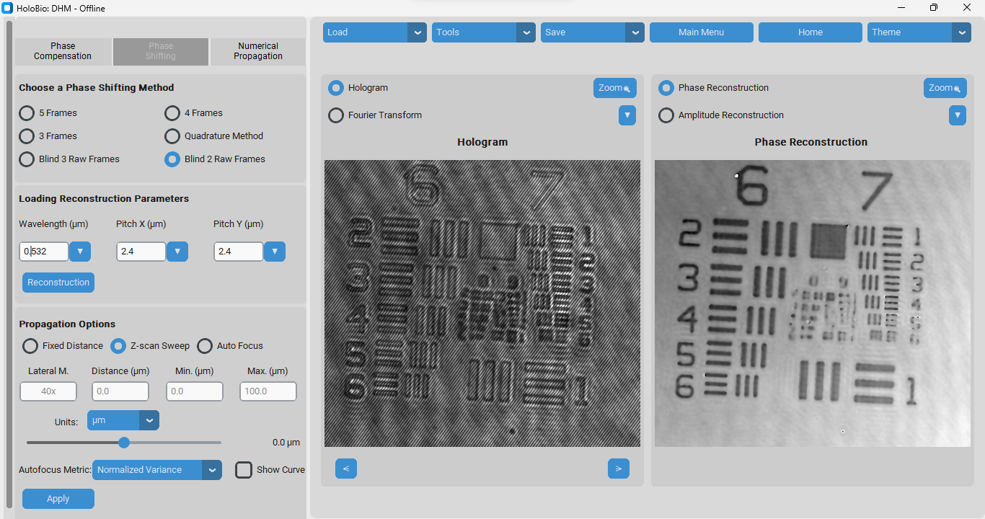

Fig. 9. Phase Shifting method displayed in the Offline DHM interface of HoloBio.

# Numerical Propagation

When the *Numerical Propagation method* is selected in the Offline DHM module, the Processing Methods Panel is updated with controls designed for the propagation of optical fields (Fig. 10).

|  |
| --- |
| 4. OFFLINE HOLOGRAM PROCESSING - DHM |

The panel includes the following sections:

* Choose a Propagation Method: Provides radio-button options to select the algorithm used for propagation. Available configurations include Angular Spectrum and Fresnel.
* Loading Physical Parameters: Allows the user to define key acquisition values:
  + Wavelength (λ): wavelength of the illumination source.
  + Pitch X and Pitch Y: pixel size of the digital camera in each axis.
* Propagation Options: Determines how the optical field is numerically propagated:
  + Fixed Distance, Z-scan Sweep, or Auto Focus modes.
  + Additional parameters include Lateral Magnification, Distance, Min/Max range, and selectable Units (e.g., µm).
  + An Autofocus Metric can be chosen (e.g., Normalized Variance), with the option to enable Show Curve for visualization of the focus evaluation.

Note: The rest of the interface remains consistent, with the Main Control Panel (Panel 1) available for general operations and the Visualization Panel (Panel 3) displaying either the loaded hologram/Fourier transform (left) or the corresponding amplitude/phase reconstruction (right).

How to use it?

Step 1 – Load an Image.

Step 2 – Define the propagation method.

Step 3 – Configure the physical parameters.

Step 4 – Define the propagation options.

Step 5 – Run the numerical propagation.

In the Visualization Panel, use the left window to review the Hologram/FT and the right window to toggle between Amplitude and Phase.

|  |
| --- |
| 4. OFFLINE HOLOGRAM PROCESSING - DHM |

|  |
| --- |
| 4. OFFLINE HOLOGRAM PROCESSING - DHM |



Fig. 10. Numerical Propagation method displayed in the Offline DHM interface of HoloBio.

Practical Example - Numerical Propagation: To demonstrate the use of the Numerical Propagation method in the Offline DHM module, Fig. 11 shows the propagation of a simulated coherent image designed to evaluate diffraction patterns. In this case, the Angular Spectrum method was selected. The input parameters included a laser wavelength of λ = 532 nm and a camera pixel size of 6.5 µm. In the Propagation Options panel, the Fixed distance mode was enabled, with a value of 5000 µm.



Fig. 11. Offline DHM interface using the Numerical Propagation module.

|  |
| --- |
| 4. OFFLINE HOLOGRAM PROCESSING - DHM |

# Propagation Options

The Propagation Options panel allows users to numerically propagate the reconstructed optical field by choosing among different modes (Fixed Distance, Z-scan Sweep, and Auto Focus). This tool is shared across the Phase Compensation, Phase Shifting, and Numerical Propagation modules.

* Fixed Distance: Reconstructs the field at a single specified axial distance.
* Z-scan Sweep: Propagates the field across a range of distances defined by Min and Max, generating multiple propagations.
* Auto Focus: Automatically finds the optimal focus plane using a selected sharpness metric (Normalized Variance, Tenengrand).

Input Parameters:

* Lateral Magnification: Defines the optical magnification used during acquisition of the hologram (e.g., 40x).
* Distance (µm): Indicates the numerical propagation distance when using Fixed Distance mode.
* Min (µm) / Max (µm): *Specify the lower and upper bounds of the axial range for the Z-scan Sweep.*
* Units: Allows the user to select the unit system for distance (e.g., µm).
* Show Curve: Displays the sharpness metric curve across the scanned range, helping the user visualize and confirm the selected focal plane.

How to use it?

* **Fixed Distance**

Step 1 – Select the Fixed Distance option in the Propagation panel.

Step 2 – Enter the Lateral Magnification of the optical system (e.g., 40x).

Step 3 – Specify the Propagation Distance at which you want to reconstruct the field.

Step 4 – Click Apply. The software will generate the numerical reconstruction of the optical field at the selected distance.

* **Z-scan Sweep**

Step 1 – Select the Z-scan Sweep option in the Propagation panel.

Step 2 – Enter the Lateral Magnification of the system.

Step 3 – Define the Min and Max distances to establish the axial scanning range.

Step 4 – Click Apply. The system will propagate the field across the specified range.

Step 5 – Use the slider bar to browse through the reconstructed fields.

* **Auto Focus**

Step 1 – Select the Auto Focus option in the Propagation panel.

Step 2 – Enter the Lateral Magnification of the system.

|  |
| --- |
| 4. OFFLINE HOLOGRAM PROCESSING - DHM |

Step 3 – Define the Minimum (µm) and Maximum (µm) distances that set the axial range where autofocus will be evaluated.

Step 4 – Choose a Sharpness Metric (e.g., Normalized Variance or Tenengrad).

Step 5 – (Optional) Select Show Curve if you wish to display the sharpness metric across the scanned range.

Step 6 – Click Apply. An image will appear prompting you to select the Region of Interest (ROI) where autofocus should be evaluated. The software will then calculate and display the optimal focal plane.

|  |
| --- |
| 5. OFFLINE HOLOGRAM PROCESSING - DLHM |

Selecting the *Offline DLHM* option in the Main Menu opens the interface shown in Fig. 12. This workspace is structured into three main components that support reconstruction under the DLHM framework.

* Main Control Panel (1): Positioned at the top of the interface, this toolbar centralizes key actions. It includes options to load holograms, access auxiliary tools, save results (Fourier Transform, phase, or amplitude reconstructions), return to the main menu or home screen, and switch interface themes.
* Parameters Panel (2): Located on the left side of the interface, this panel provides input fields and sliders for defining the physical parameters of the reconstruction process. Users can configure wavelength, pixel pitch (X and Y), magnification, and distances between system components (camera-source distance *L*, sample distance *Z*, and reconstruction distance *r*). Additional options allow the selection of algorithms (Angular Spectrum, Kreuzer Method, DLHM) and setting global bounds for distance values.
* Visualization Panel (3): Occupying the central and right sections of the workspace, this panel serves as the main display area. On the left side, users can toggle between the hologram view and its Fourier transform. On the right side, users can select either phase or amplitude reconstructions. Zoom functions are available in both visualization windows, enabling detailed inspection of holographic data.

How to use it?

Step 1 – Load data.

Step 2 – Define physical parameters (Parameters Panel).

Step 3 – Choose reconstruction method.

Step 5 – Run reconstruction 🡪 Click on Reconstruction button.

In the Visualization Panel, use the left window to review the Hologram/FT and the right window to toggle between Amplitude and Phase.



Fig. 12. Offline DLHM method displayed in the interface of HoloBio.

|  |
| --- |
| 5. OFFLINE HOLOGRAM PROCESSING - DLHM |

Practical Example - DLHM Reconstruction: To illustrate the use of the Offline DLHM module, Fig. 13 presents the reconstruction of *Paramecia* swimming in water, obtained from a previously recorded hologram. The reconstruction was performed using the Kreuzer Method, with the following parameters: wavelength λ = 532 nm, pixel size = 6.9 µm in both axes, and source-to-camera distance L = 20 mm. The source-to-sample distance was set to Z = 6.8 mm, corresponding to the focal plane of the middle paramecia.



Fig. 13. Offline DLHM method displayed in the interface of HoloBio.

|  |
| --- |
| 6. REAL-TIME HOLOGRAM PROCESSING - DHM |

Selecting the *Real-time DHM* option on the Main Menu opens the interface shown in Fig. 14. This workspace is designed to support the live acquisition and real-time reconstruction of holograms recorded in off-axis and telecentric architectures, using a connected camera. It is organized into three main components that facilitate dynamic phase compensation, visualization, and particle tracking workflows:

* **Main Control Panel (1):** Located at the top of the interface, this panel contains the primary operational controls. For more details about its function, refer to the *Common Interface Components* section.
* **Processing and Control Panel (2):** Positioned on the left side of the window, this panel includes all the controls required for real-time operation. It is divided into functional sections:
  + Parameters: Input fields for wavelength and camera pixel pitches (X and Y).
  + FT Visualization Options: Selection of spatial filter geometry and toggles for viewing filtered or unfiltered Fourier transforms.
  + Compensation Controls: Buttons to start phase compensation and manage playback (Play/Stop).
  + Record Options: Controls to record videos of hologram, amplitude or phase reconstructions in real time.
  + Particle Tracking: Tools for tracking micro-particles, including filter selection, area thresholds, Kalman filter parameters, color filtering, and magnification options.
* **Visualization Panel (3):** Occupying the central and right sections of the interface, this panel provides two synchronized display windows. For more details about its function, refer to the *Common Interface Components* section.



Fig. 14. Real-Time DHM workspace with compensation controls.

|  |
| --- |
| 6. REAL-TIME HOLOGRAM PROCESSING - DHM |

6.1 Compensation of Holograms from Digital Camera

This option enables the user to perform phase compensation on holograms acquired directly from a digital camera connected to the computer. To initialize the acquisition, click Load > Init Camera. The system will automatically detect the available camera and establish the connection for real-time hologram capture. Once the camera is active, the user can input the required reconstruction parameters (e.g., wavelength and pixel pitch) and press the Compensate button to initiate phase compensation.

During this process, the hologram is continuously captured from the live camera feed and processed in real-time, allowing immediate visualization and adjustment of parameters as needed.

Note: Ensure that the digital camera drivers are correctly installed on the computer prior to use. Proper installation of the manufacturer’s drivers is necessary for HoloBio to recognize the camera and establish a stable connection.

6.2 Compensation for Previously Recorded Holograms

This option allows the user to perform phase compensation on holograms acquired previously and stored as video files. To begin, click Load > Load Video, then select the desired hologram video from local storage. Once the video is loaded, the user must enter the reconstruction parameters (e.g., wavelength, pixel pitch) and press the Compensate button to start the phase compensation process.

When working with recorded holograms, the system provides several playback options on *Compensation Controls panel* that can be useful before initiating the compensation:

* Play: Starts video playback without applying any compensation. This is useful for previewing the content and identifying the region or frame of interest.
* Pause: Temporarily halts playback. This feature enables the user to stop at a specific frame and begin compensation from that point.
* Stop: Completely terminates the playback. If the Stop button is pressed, the video must be reloaded before compensation can be applied.

6.3 Particle Tracking

The Particle Tracking module enables the detection and trajectory analysis of particles over time from video sequences. This tool can be applied to videos of reconstructed Phase, Amplitude, or even directly to the original Hologram. To begin, the user must load the desired video by clicking Load > Load Video, complete the required parameters in the Particle Tracking Panel, and press Tracking to start the process.

The Particle Tracking tool combines filtering options, size constraints, and Kalman filter parameters to ensure accurate trajectory estimation.

* **Filter Method:** Provides two options to reduce background noise (speckle).

|  |
| --- |
| 6. REAL-TIME HOLOGRAM PROCESSING - DHM |

* **Gaussian Filter:** Reduces high-frequency noise and softens edges, but may blur contours.
  + Bilateral Filter: Smooths noise while preserving sharp edges; more computationally expensive but better suited for samples with fine details.
* Color Filtering: When enabled, the user must specify the polarity of the objects relative to the background by setting the Blob Color. Use 0 if the background is light and the particles are dark, or 255 if the background is dark and the particles are light.
* Min Area / Max Area: Define the size range (in pixels) for valid particles. Only objects within this range will be detected and tracked.
* Kalman Filter Parameters: Control the behavior of the tracking algorithm by modeling system and measurement uncertainties.
* **P (State Covariance):** Initial uncertainty in particle positions. High values make the filter adapt quickly to new measurements; low values make it trust the initial state.
* **Q (Process Noise):** Models irregularities in particle motion. High values allow adaptation to rapid or erratic movement; low values assume smooth trajectories.
* **R (Measurement Noise):** Represents detection uncertainty. High values make the filter rely more on predictions; low values make it follow measurements closely.
* World Coordinates: If enabled, particle positions are reported in real-world units instead of pixels.
* Magnification (M): Defines the optical magnification used during acquisition (e.g., 40x).

Practical Recommendation:

* Use moderately high values (e.g., P = 100 - 400) unless the initial particle positions are known with high certainty.
* Use a higher Q when tracking particles in turbulent environments or with irregular motion. And use a lower Q for smooth, predictable trajectories.
* Increase R if your detection method sometimes produces false positives or misses frames. And decrease R if detections are precise and stable across frames.

Table 1. Kalman Filter parameters and their recommended ranges.

|  |  |  |  |  |  |
| --- | --- | --- | --- | --- | --- |
| P | | Q | | R | |
| 1-50 | Very reliable initial positions and clear detection | 0.01-1 | Very smooth movement, without abrupt changes | 0.1-2 | Highly accurate detection |
| 100-400 | Moderate unfamiliarity with the initial state | 1-10 | Moderately erratic movement | 5-10 | Some noise or inconsistent detection |
| > 500 | High uncertainty in the initial position of the particles | > 10 | Unpredictable motion or strong accelerations | >20 | Very unstable detection or frequent false positives |

|  |
| --- |
| 6. REAL-TIME HOLOGRAM PROCESSING - DHM |

How to use it?

Step 1 – Load the video: In the Main Control Panel, click Load → Load Video and select the hologram, amplitude, or phase reconstruction sequence you wish to analyze. The video will appear in the Visualization Panel.

Step 2 – Define Particle Tracking parameters: Filter Method, Color Filtering, Min Area / Max Area, Kalman Filter Parameters: Adjust P, Q, and R according to the expected motion and detection reliability, World Coordinates (optional): Enable if results should be expressed in real-world units. Magnification (M): Input the optical magnification used during acquisition (e.g., 40x).

Step 3 – Start tracking: Click the Tracking button to begin particle detection and trajectory estimation.

Practical Example: Tracking of micro-compositos

Once the tracking process is initiated, the workflow unfolds as illustrated in Fig. 15. Panels (a–d) display successive frames of the video sequence, where individual particles are automatically detected and highlighted with colored markers. As the video progresses, the system identifies the displacement of each particle and links their positions frame by frame. Panel (e) shows the resulting particle trajectories plotted in the spatial domain (X–Y), where each track is assigned a unique color and index number for easy interpretation. Finally, panel (f) presents the Positions Vector Table, which records the detailed numerical results, including frame number, elapsed time, and the X–Y coordinates of all tracked particles across the video sequence.

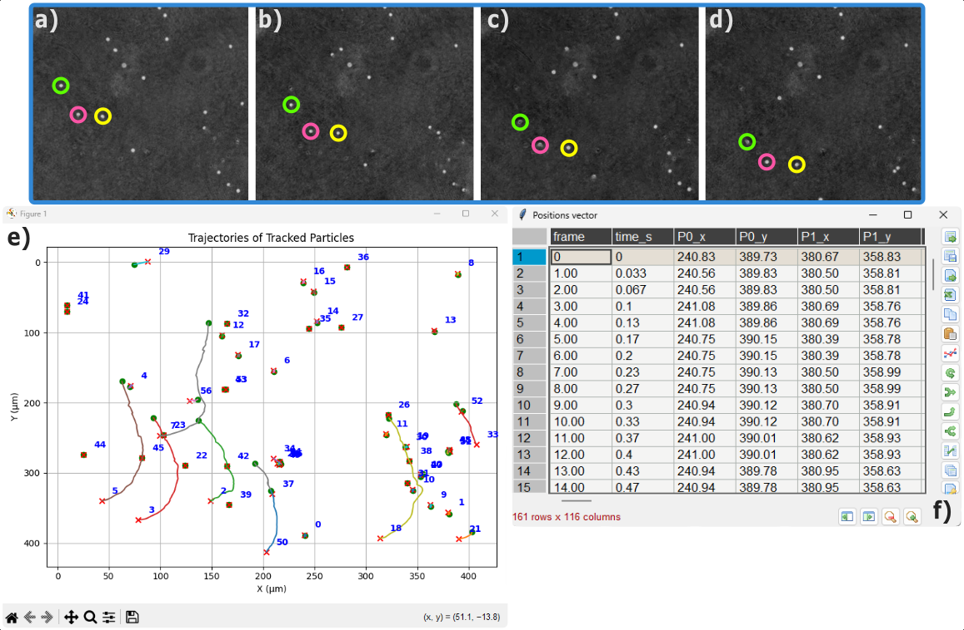

Fig. 15. Workflow of the particle tracking process in HoloBio.

|  |
| --- |
| 7. HoloBio AnalysisToolkits |

7.1 Bio-Analysis

The Bio-Analysis provides tools for extracting quantitative biological information from numerical reconstructions. It currently includes three functions: i) Dimensions, ii) QPI Measurements, and iii) Microstructure Metrics, as shown in Fig. 16.

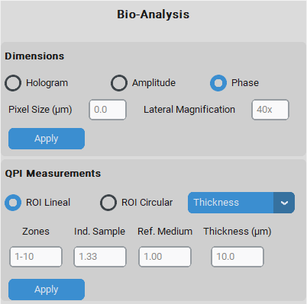

**i) Dimensions:** The Dimensions tool allows the user to obtain measurements of the physical dimension of the specimen. Select whether the measurements will be based on the Hologram, the reconstructed Amplitude, or the Phase image.

* **Pixel Size (µm):** Defines the dimension of the pixel size of the camera used for acquisition.
* **Lateral Magnification:** Indicates the optical magnification applied during the acquisition (e.g., 40x).

How to use?  
Step 1 – Define Parameters.

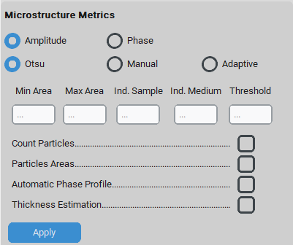Step 2 – Adjust the Scale Bar.

Step 3 – Perform Measurements.

Fig. 17. illustrates the use of the *Dimensions* panel. In panel (a), once the pixel size and lateral magnification are defined, the Apply button updates the image scaling so that subsequent analyses are expressed in real-world units. By default, a scale bar is displayed on the image. This bar can be modified in two ways: by left-clicking, the user may adjust its length (panel b, right), and by right-clicking, the user can change its color (available options: white, black, or red; panel b, left). After applying the dimensions, users can draw lines between two points in the image to measure distances within the sample. Panel (d) shows examples of measured cell diameters, while panel (c) presents zoomed views of two selected regions to highlight the computed values.

Fig. 16. Bio-Analysis panel of the HoloBio interface.

|  |
| --- |
| 7. HoloBio AnalysisToolkits |
|  |

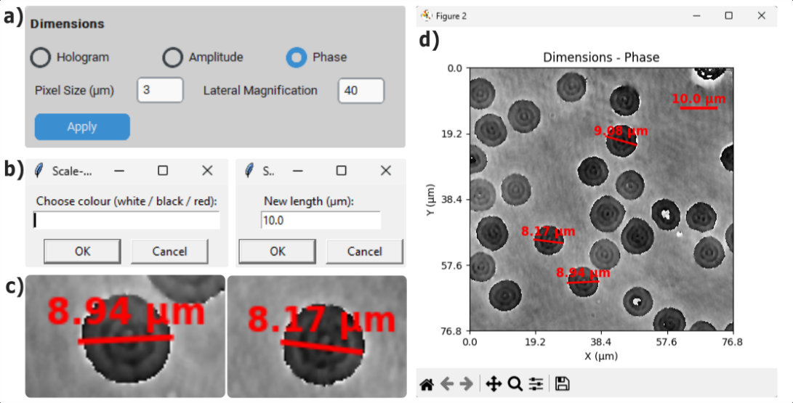

Fig. 17. Workflow of the Dimensions tool in HoloBio. (a) shows the selection of the measurement mode and magnification parameters. (b) illustrates the scaling options for color and reference length. (c) displays examples of individual particle size measurements. (d) presents the resulting dimension annotations over the reconstructed phase image.

ii) QPI Measurements: The QPI (Quantitative Phase Imaging) Measurements section allows users to extract phase profiles, perform thickness or refractive index–based analyses within a selected Region of Interest (ROI).

* **ROI Selection:** Allows the user to select the geometry of the measurement region, either Lineal or Circular, which determines how the phase profile will be extracted for quantitative analysis.
* Measurement Mode: Specifies the type of quantity the user wants to evaluate. Two options are available (Thickness and Refractive Index).
* Input Parameters: The active fields depend on the selected *Measurement Mode.*
* If Thickness is selected → the fields **Ind. Sample** (refractive index of the sample) and **Ref. Medium** (refractive index of the surrounding medium) become available.
* If Refractive Index is selected → the field **Thickness** is enabled to provide the sample thickness.
* Zones are always available to define the range of regions to be analyzed.

By clicking Apply, the system computes and displays the selected measurement, enabling quantitative analysis of biological specimens.

How to use?  
Step 1 – Define ROI.

|  |
| --- |
| 7. HoloBio AnalysisToolkits |

Step 2 – Select Measurement Mode.

Step 3 – Enter Input parameters.

Step 4 – Perform Measurements.

Fig 18. illustrates the use of the QPI Measurements panel. In panel (a), the user selects the ROI geometry (linear or circular), chooses the measurement mode (e.g., thickness), and defines the required input parameters such as Ind. Sample, Ref. Medium. Once the parameters are set, pressing Apply enables the extraction of quantitative phase information. Panel (c) shows how users can define line profiles by selecting two points within the image. Each profile corresponds to a region of the sample where the phase variation will be analyzed. The resulting phase profiles are plotted in panel (d), displaying the phase distribution as a function of distance for the selected ROIs. Finally, panel (b) presents the QPI results table, which summarizes key numerical values for each zone, including minimum, maximum, and average phase.



Fig. 18. Workflow of the QPI Measurements in HoloBio. (a) shows the selection of ROI geometry, measurement mode, and input parameters. (b) presents the QPI results table summarizing numerical values, including minimum, maximum, and average phase for each zone. (c) illustrates the definition of line profiles on the sample image for phase analysis. The corresponding phase distributions as a function of distance are plotted in (d).

iii) Microstructure Metrics: Microstructure Metrics enables quantitative characterization of biological structures from amplitude or phase reconstructions through automated segmentation and targeted measurements, including particle counting, area estimation, phase profiling, and thickness mapping.

* Input Image Selection: The user can choose whether the analysis will be performed on the Amplitude or the Phase image.
* Segmentation Mode: Three segmentation options are available:
  + Otsu: Automatically determines the threshold based on image statistics.
  + Manual: Requires the user to input a threshold value.
  + Adaptive: Applies a locally adaptive thresholding method.
* Input Parameters:
  + Min Area / Max Area: Define the minimum and maximum particle size to be considered during analysis.

|  |
| --- |
| 7. HoloBio AnalysisToolkits |

* + Ind. Sample / Ind. Medium: Optional fields for entering the refractive indices of the sample and the surrounding medium, used in thickness estimation.
  + Threshold: Manually entered value when the *Manual* segmentation mode is selected.
* Measurement Options:
  + Count Particles: Computes the number of detected particles.
  + Particles Areas: Calculates the area of each segmented particle.
  + Automatic Phase Profile: Extracts phase profiles for each detected region.
  + Thickness Estimation: Provides an estimation of thickness based on phase information and input refractive indices.

The following subsections illustrate the four analysis workflows available within the Microstructure Metrics module. Each workflow demonstrates how the segmentation and measurement tools are applied to extract quantitative information from reconstructed amplitude or phase images.

How to use it?

Step 1 - Select the input image (Amplitude or Phase).

Step 2 - Choose the segmentation mode (Otsu, Manual, or Adaptive).

Step 3 - Define the input parameters (area range, indices, threshold if required).

Step 4 - Select the desired measurement options.

Step 5 - Click Apply to perform the analysis and obtain the results.

a. Count Particles

When the user selects Count Particles and clicks Apply, the system automatically initiates a sequence of steps for particle detection. The workflow is illustrated in Fig. 19. Panel (a) displays the Histogram with Threshold, where the selected segmentation method (e.g., Otsu) determines the threshold line used for binarization. Panel (b) shows the Binarized Image, in which objects appear in black or white depending on the thresholding result. Next, a Sample Polarity Dialog (panel c) asks the user to confirm whether the particles of interest are represented as white (w) or black (b), ensuring correct interpretation of the mask. Once polarity is confirmed, the system generates the Connected Components view (panel d, left), where each detected particle is color-coded and assigned a unique label. The Detected Samples Visualization (panel d, right) overlays red contours, IDs, and centroids onto valid particles, showing only those that meet the user-defined constraints (e.g., minimum and maximum area). Finally, a Detection Summary window (panel e) provides numerical information, including the threshold value, number of detected particles, and the count of particles that fall within the specified area range.

|  |
| --- |
| 7. HoloBio AnalysisToolkits |

|  |
| --- |
| 7. HoloBio AnalysisToolkits |

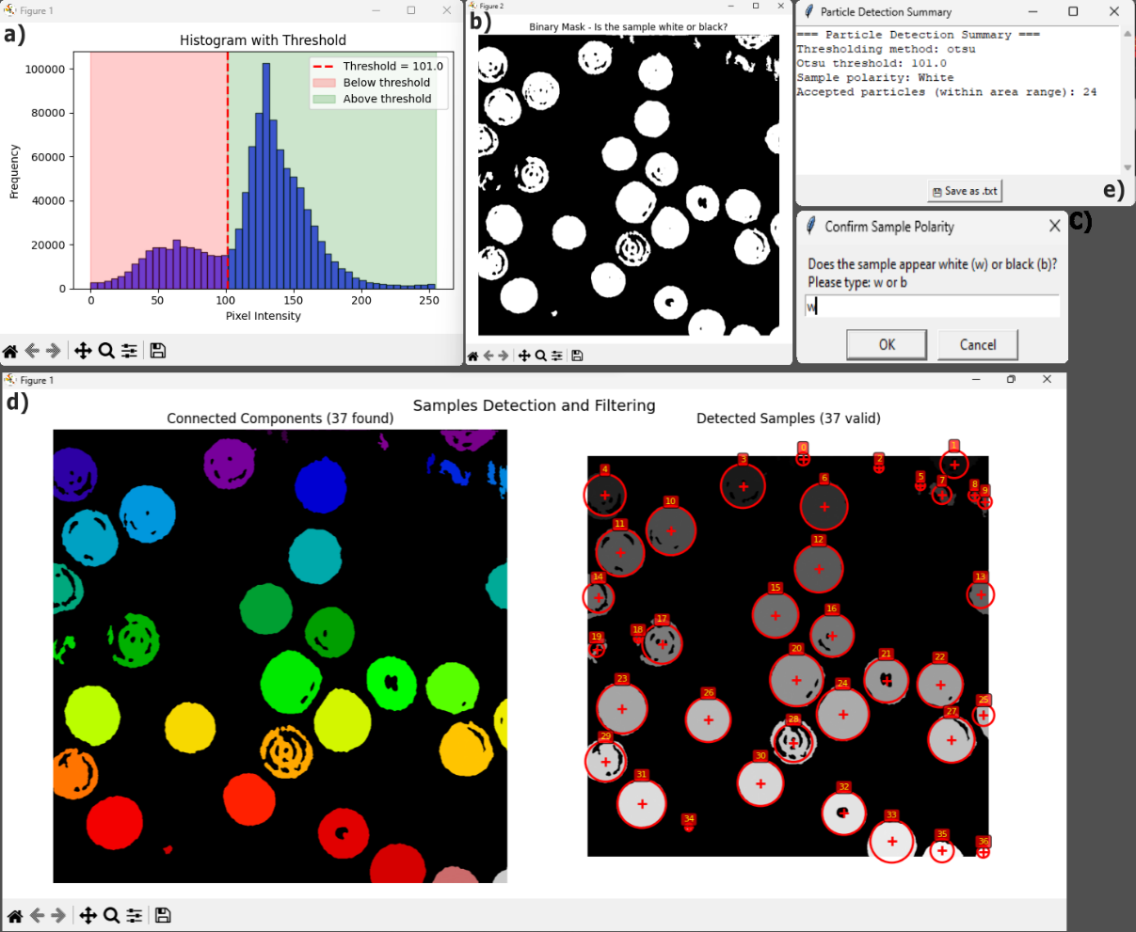

Fig. 19. Workflow of the particle detection module in HoloBio. (a) shows the histogram with threshold used for binarization. (c) presents the binarized image, while (c) illustrates the sample polarity confirmation dialog. (d, left) displays the connected components view with color-coded labels, and (d, right) shows the detected samples visualization with contours, IDs, and centroids of valid particles. Finally, (e) provides the detection summary with numerical results including threshold value and particle counts.

b. Particles Areas:

When the user selects Particles Areas and clicks Apply, the system automatically launches a workflow for calculating the size of each detected particle. The process is illustrated in Fig. 20. Panel (a) displays the Binarized Image, where objects appear in black or white depending on the chosen segmentation method and polarity. Once the polarity is confirmed, the system generates the Connected Components view (panel b, left), in which each detected particle is color-coded and labeled, and the Detected Samples Visualization (panel b, right), where valid particles are highlighted with red contours, IDs, and centroid markers. Panel (c) shows the Distribution of Particle Areas, represented as a histogram that summarizes the frequency of occurrence for different particle sizes. Panel (d) presents the Particle Data Table, listing for each particle its ID, centroid

|  |
| --- |
| 7. HoloBio AnalysisToolkits |

coordinates (X, Y), measured area (in µm²), and estimated diameter. Finally, as part of the workflow, a Sample Polarity Dialog (panel e) ensures correct interpretation by asking the user to specify whether the objects of interest are represented as white (w) or black (b).

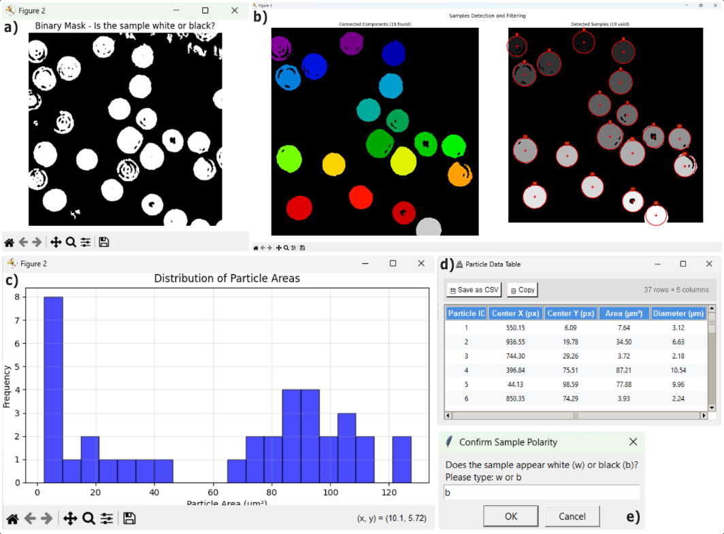

Fig. 20. Particle analysis workflow in HoloBio. (a) shows the binarized image generated after thresholding and polarity selection. (b, left) presents the connected components view with color-coded labels, and (b, right) displays the detected samples visualization with contours, IDs, and centroids of valid particles. (c) illustrates the distribution of particle areas as a histogram. (d) shows the particle data table with centroid coordinates, area, and diameter values. (e) depicts the sample polarity dialog for confirming correct interpretation of the mask.

c. Automatic Phase Profile:

When Automatic Phase Profile is selected and the user clicks Apply, HoloBio runs a fully automated routine to extract phase profiles across each valid particle and to estimate the phase shift Δφ per sample. The sequence is shown in Fig. 21. (a) Binary Mask. The input phase image is thresholded using the chosen segmentation method (Otsu, Manual, or Adaptive). A polarity dialog prompts the user to confirm whether the objects of interest correspond to white regions on a dark background or vice versa, ensuring correct interpretation. (b) Valid Profile Lines. For every particle detected, the algorithm searches for a suitable line passing through the object that connects background regions on both sides without intersecting other particles. These lines (shown in color) represent the

|  |
| --- |
| 7. HoloBio AnalysisToolkits |

sampling geometry used to compute phase differences. White circles mark the detected particles. (c) Phase Shift Summary. For each valid profile, the system computes the phase-shift Δφ as the difference between plateau regions across the line. A summary window lists all valid samples and their respective Δφ values in radians. (d) Connected Components and Filtering. The left panel displays the labeled connected components found in the mask, each color-coded for visualization. The right panel shows the detected and validated samples, highlighted with red circles, centroids, and IDs. Only particles meeting the size criteria (Min/Max Area) and yielding valid profiles are retained for analysis.

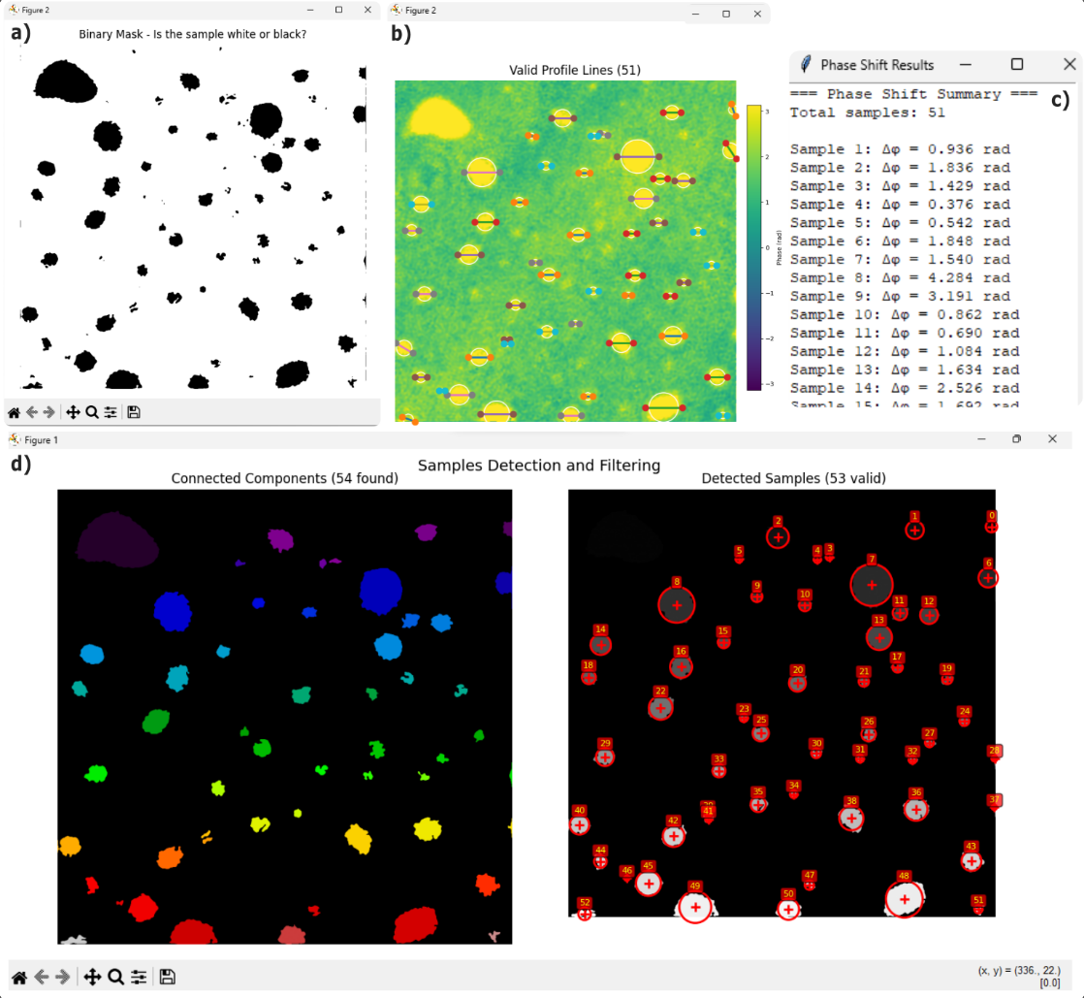

Fig. 21. Automatic phase profile workflow in HoloBio. (a) Binary mask generated after thresholding and polarity confirmation. (b) Valid profile lines placed across particles with fitted circles. (c) Phase-shift summary window listing Δφ values for each sample. (d, left) Connected components view; (d, right) final detected samples with IDs, centroids, and validation contours.

|  |
| --- |
| 7. HoloBio AnalysisToolkits |

d. Thickness Estimation:

When the user selects Thickness Estimation and clicks Apply, the system automatically initiates a workflow to calculate the optical thickness of each detected particle. The procedure is illustrated in Fig. 22. Panel (a) shows the Binarized Image, generated according to the selected segmentation method and polarity, where particles are separated from the background. Once polarity is confirmed (panel d), the algorithm computes the Delta Phase (Δφ) Map, displayed in panel (b), which represents the phase difference between the sample and the surrounding medium. From this phase information, the software derives the Estimated Thickness Map (panel c), where the optical thickness of each particle is calculated in micrometers based on the input refractive indices provided by the user. The resulting thickness values are displayed with a color scale, enabling both qualitative visualization and quantitative estimation of microstructural properties.

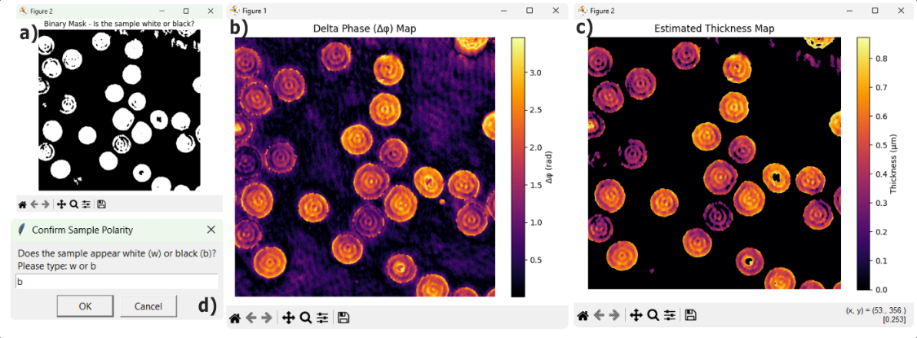

Fig. 22. Thickness estimation workflow in HoloBio. (a) shows the binarized image used to separate particles from the background. (b) displays the Δφ (Delta Phase) map, representing the phase difference between the sample and the surrounding medium. From this information, the software generates the estimated thickness map (c), where the optical thickness of each particle is calculated and displayed in micrometers using a color scale. (d) illustrates the polarity confirmation dialog.

7.2 Filters

The Filters provides tools for enhancing images (Holograms, Amplitude or Phase) through spatial and intensity-based filtering. It currently includes two functions: Adjust Image Filters and Visualization Color Mode (Fig. 23).

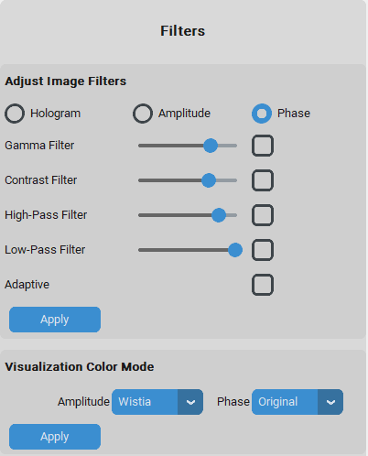

Fig. 23. HoloBio Filters panels.

* + 1. **Adjust Image Filters:** The Adjust Image Filters tool allows the user to apply different filtering techniques. These filters are intended to improve visibility and highlight structural details.
* **Gamma Filter:** Controls the value of γ (gamma), which adjusts the relationship between dark and bright intensities in the image. The applied equation is:

$I_{Out}=255 × {\left(\frac{I}{I_{Max}}\right)}^{γ}$,

where, *I* is the pixel intensity of the original image, *IMax* is the maximum intensity (for normalization), and *Iout* is the corrected pixel value.

* If γ > 1 → the image becomes brighter (output intensities are expanded).
* If γ < 1 → the image becomes darker (output intensities are compressed).
* **Contrast Filter:** Controls contrast factor *CT*, stretching or compressing pixel values around the mean intensity.

The applied equation is:

$I_{Out}=\left(I- μ\right) ×CT+μ$,

where *I* is the pixel intensity, *μ* is the mean intensity of the original image, *CT* is the slider value, and *Iout* is the adjusted intensity.

* **High-Pass Filter:** Controls the cutoff radius of a circular mask in the Fourier domain. Low-frequency components (smooth background variations) are suppressed, while high-frequency components (edges and fine details) are preserved. Increasing the cutoff radius allows more high frequencies to pass through, enhancing details but potentially amplifying noise.
* **Low-Pass Filter:** Controls the cutoff radius of a circular mask in the Fourier domain. High-frequency components (fine details and noise) are suppressed, while low-frequency components (global variations) are preserved. Reducing the cutoff radius smooths the image and improves clarity, but may also remove fine structural information.
* **Adaptive:** Controls the histogram equalization to redistribute pixel intensities across the available dynamic range, enhancing contrast in saturated or low-contrast regions.The applied equation is:

$I_{out}=I_{min}{+ \left(I_{max}{-I_{min} }\right)} CDF \left( \frac{I_{in}-I_{min}}{I_{max}-I_{min}}\right)$,

where $I_{in}$ is the input pixel intensity, $I_{min}$ ​ and $I_{max}$ ​ are the minimum and maximum intensities of the image, $CDF$ is the cumulative distribution function of the normalized histogram, and $I_{out}$ ​ is the adjusted pixel intensity. This transformation expands densely populated intensity ranges (increasing local contrast) and compresses less populated ones, while preserving the relative order of intensities.

How to use it?

Step 1 – Select the image type (Hologram, Amplitude, or Phase).  
Step 2 – Adjust the desired filters using the sliders and checkboxes.  
Step 3 – Click Apply to visualize the filtered result.

|  |
| --- |
| 7. HoloBio AnalysisToolkits |

|  |
| --- |
| 7. HoloBio AnalysisToolkits |

|  |
| --- |
| 7. HoloBio AnalysisToolkits |